NOTE: Triggers are being fixed right now. Please avoid using the triggers until the code is updated. I will let you guys know as soon as it is fixed 😊

1. Install SQL Server Management Studio with default settings: [Download SQL Server Management Studio (SSMS) - SQL Server Management Studio (SSMS) | Microsoft Learn](https://learn.microsoft.com/en-us/sql/ssms/download-sql-server-management-studio-ssms?view=sql-server-ver16)
2. Install SQL Server 2022: [SQL Server Downloads | Microsoft](https://www.microsoft.com/en-us/sql-server/sql-server-downloads)
3. After connecting to the local server instance, then click on “Connect to Database Engine” in SSMS:

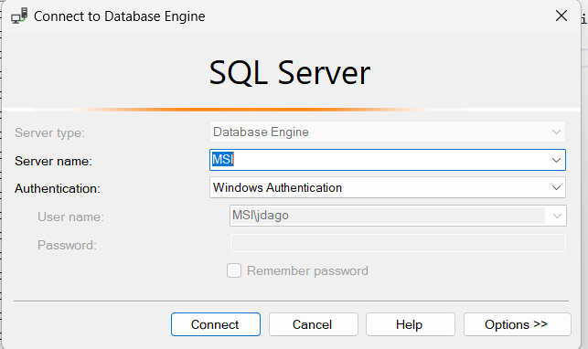

1. Right click on “Databases” and create “New Database” with default settings
2. Click on “New Query” to create the database schema
3. Insert the following tables into the database:

CREATE TABLE Patient (

email_address VARCHAR(50) PRIMARY KEY,

password VARCHAR(12),

first_name varchar(15),

last_name varchar(15),

birth_date DATE,

clinician_name varchar(15),

insurance_comp varchar(25),

user_type VARCHAR(10) DEFAULT 'Patient'

)

CREATE TABLE Clinician (

email_address VARCHAR(50) PRIMARY KEY,

password VARCHAR(12),

first_name VARCHAR(15),

last_name VARCHAR(15),

birth_date DATE,

NPI_number INT,

employer_name VARCHAR(50),

user_type VARCHAR(10) DEFAULT 'Clinician'

)

CREATE TABLE Login (

email_address VARCHAR(50) PRIMARY KEY,

password VARCHAR(12),

user_type VARCHAR(10),

FOREIGN KEY (email_address) REFERENCES Patient(email_address) ON DELETE CASCADE,

FOREIGN KEY (email_address) REFERENCES Clinician(email_address) ON DELETE CASCADE

);

1. Set up the triggers for new Patient and Clinician entries

CREATE TRIGGER trgAfterInsertPatient

ON Patient

AFTER INSERT

AS

BEGIN

INSERT INTO Login (email_address, password, user_type)

SELECT email_address, password, 'Patient'

FROM inserted;

END;

CREATE TRIGGER trgAfterInsertClinician

ON Clinician

AFTER INSERT

AS

BEGIN

INSERT INTO Login (email_address, password, user_type)

SELECT email_address, password, 'Clinician'

FROM inserted;

END;

1. Generate a fake patient to test out the Patient table

USE HealthPortalAuthenticate;

INSERT INTO Patient (email_address, password, first_name, last_name, birth_date, clinician_name, insurance_comp)

[VALUES('chatham2002@gmail.com](mailto:VALUES('chatham2002@gmail.com)', 'HashItOut', 'Chatham', 'Savannah', '04/20/2000', 'Dr.Pellegrino', 'BlueGuardTennessee');

1. Perform select all statement to determine if table was created successfully



1. Perform select all statement to determine if trigger worked correctly for Patient -> Login